

October 1, 2024

|  |  |
| --- | --- |
| **Created by** | Yogesh Gunjal |
| **Contact** | +49 163 9061226  <mailto:passionatefordata@gmail.com> |
| **Date** | 01.10.2024 |
| **Created for** | TUI Cruises  Heidenkampsweg 58, 20097 Hamburg |
| **Position Applied For** | Intern Fleet Energy Performance and Data Science |
| **Technologies Used** | Python (Google Colab), Microsoft Power BI |

Performance Analysis of Fleet Energy and Efficiency for

TUI Cruises

Contents

Executive Summary 2

Folder Structure 2

Dataset Overview 2

Key Columns in the Dataset 2

Power Generation Analysis 4

Fuel Flow Analysis 7

Power Consumption Analysis 10

Environmental Impact Analysis 15

Navigation and Vessel Performance 19

Geospatial Analysis 24

# Executive Summary

This analysis focuses on the energy performance of two vessels in TUI Cruises' fleet, to identify trends, and inefficiencies, in fuel consumption, power generation, and overall vessel performance. Leveraging data from various ship components, environmental conditions, and navigation metrics.

# Folder Structure

The repository has 3 folders:

1. Documentation - This folder includes the developer document of the project.
2. Solution – This folder includes Python notebook, Power BI report, and aggregated dataset generated using Python notebook.
3. task_data – This folder consists of Schema detail and dataset files from TUI.
4. Images – It contains the company logo and Dashboard snapshots.

# Dataset Overview

The dataset consists of 210,241 rows of recorded data, spanning from January 1, 2023, to December 31, 2024, with each record captured at 5-minute intervals. The dataset provides a comprehensive view of ship operations, covering various energy consumption, environmental, and navigational metrics for two vessels. **This analysis is based on an aggregated hourly dataset which is created in Python notebook**

Key Columns in the Dataset:

Time Data:

* Start Time and End Time: These indicate the beginning and end of each 5-minute measurement interval.
* Local Time (h): The local time onboard the vessel, which can be useful for aligning operational activities with energy usage patterns.

Vessel Data:

* Vessel Name: The specific vessel from which the data was recorded (Vessel 1 or Vessel 2).
* Latitude (Degrees) and Longitude (Degrees): These columns record the ship’s geographic position, enabling an analysis of how location impacts performance.
* Depth (m): The depth of water the vessel is navigating, which can affect resistance and, consequently, energy usage.
* Draft (m) and Trim (m): These are key ship-specific metrics that relate to how the vessel is balanced and how much of the ship is submerged, affecting propulsion efficiency.

Power Consumption:

* Power Galley 1 (MW), Power Galley 2 (MW), Power Service (MW): These fields represent power consumption in various parts of the ship (kitchen, service areas).
* HVAC Chiller 1 Power (MW), HVAC Chiller 2 Power (MW), HVAC Chiller 3 Power (MW): Power consumption for the ship’s climate control systems, which is influenced by external environmental factors.
* Scrubber Power (MW): The power consumption of the ship’s exhaust gas cleaning system.
* Propulsion Power (MW), Port Side Propulsion Power (MW), Starboard Side Propulsion Power (MW): Power consumption data specific to the ship’s propulsion system.

Fuel Flow Rates:

* Boiler 1 Fuel Flow Rate (L/h), Boiler 2 Fuel Flow Rate (L/h), Incinerator 1 Fuel Flow Rate (L/h): These represent the fuel consumption for auxiliary equipment on the ship, measured in litres per hour.
* Main Engine 1 Fuel Flow Rate (kg/h), Main Engine 2 Fuel Flow Rate (kg/h), Diesel Generator 1 Power (MW): Fuel flow rates and power output for the ship’s main engines and diesel generators, key metrics for energy efficiency analysis.

Environmental Conditions:

* Sea Temperature (Celsius): The temperature of the seawater, which affects the efficiency of the HVAC system and other ship components.
* Relative Wind Speed (knots), True Wind Speed (knots): Wind data that could influence the ship's energy consumption, particularly in propulsion.
* True Wind Direction (Degrees), Relative Wind Direction (Degrees): Wind direction data, is essential for analyzing how external conditions impact fuel and power efficiency.

Navigational Data:

* Speed Over Ground (knots) and Speed Through Water (knots): These columns provide insight into the vessel's speed relative to its surroundings and can be used to evaluate propulsion efficiency.
* Relative Wind Angle (Degrees), True Wind Angle (Degrees): These capture wind angles relative to the ship's direction, which are relevant for performance assessments.

# Power Generation Analysis

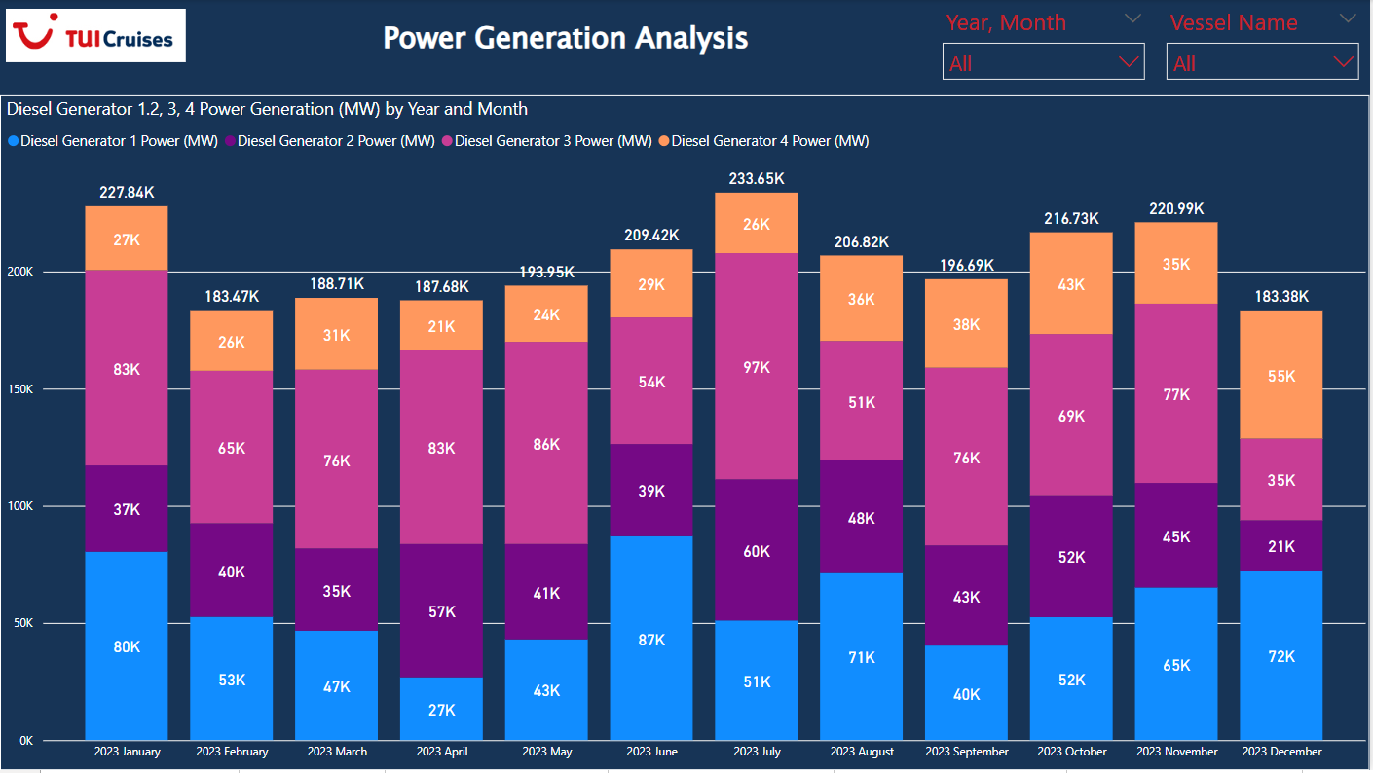

Power generation of diesel generators aboard a TUI Cruises vessel across the year 2023, categorized by month.

**Key Insights:**

* **Total Power Generation:** The vessel utilizes four diesel generators with varying power outputs. The total power generation fluctuates throughout the year, peaking in June at 233.65K (likely in Kilowatts) and hitting a low in December at around 183.38K.
* **Individual Generator Output:**
  + Diesel Generator 1 consistently contributes the most significant portion of power, followed by Generator 2.
  + Generator 3's output remains relatively stable throughout the year.
  + Generator 4 shows the most variability, indicating possible maintenance periods or strategic usage.
* **Seasonal Trends:** Power generation generally seems higher during mid-year months (May - August), suggesting increased demand possibly due to higher passenger loads or air conditioning requirements.
* **Data Filtering:** The chart offers filter options ("Year, Month" and "Vessel Name") indicating the data can be further analyzed for specific periods and vessels within the TUI Cruises fleet.

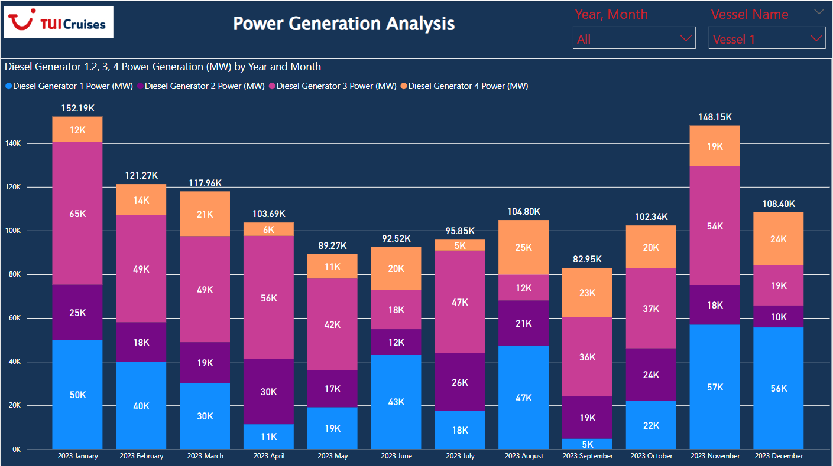

The above chart displays the power generation of Vessel 1 across the year 2023, broken down by month and further categorized by four diesel generators.

Here's a summarized analysis:

* **Overall Trend:** Vessel 1's total power generation appears to be cyclical, peaking in January and then experiencing dips and rises throughout the year. Another peak occurs in November, followed by a decrease in December.
* **Individual Generator Contributions:**
  + **Diesel Generator 1:** Consistently provides the most significant portion of power each month, ranging from around 40K to 65K MW.
  + **Diesel Generator 2:** Contributes the second-largest share, fluctuating between 18K and 54K MW. Its output seems to loosely correlate with the overall power demand.
  + **Diesel Generator 3:** Provides a relatively smaller and more stable power output, ranging from 5K to 47K MW.
  + **Diesel Generator 4:** Delivers the smallest share of power, often used minimally but showing increased contributions during peak demand months (e.g., January, November).

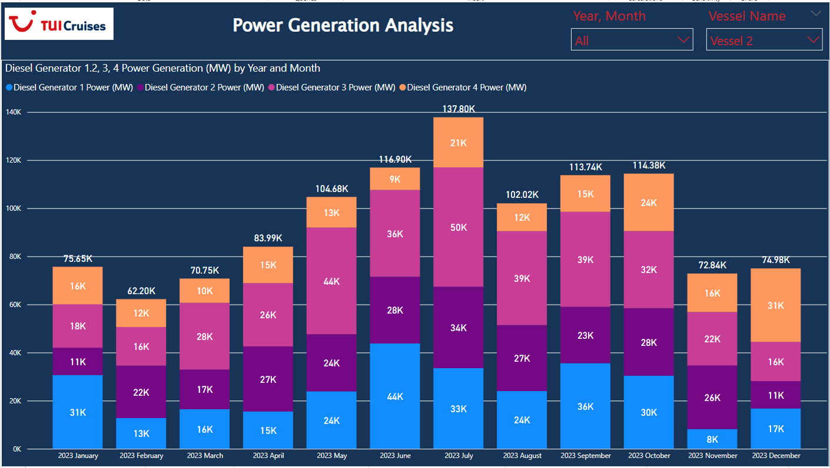

Power generation data focusing on "Vessel 2", broken down by key insights and potential interpretations:

**Key Insights**

* **Peak Power Demand:** June 2023 saw the highest total power generation (137.80K MW), indicating peak demand likely due to high passenger load or intensive ship operations during that month.
* **Seasonal Trends:** There's a noticeable upward trend in power generation from January to June, followed by a decline. This suggests a correlation with seasonal travel patterns, with summer months being busiest.
* **Generator Usage Patterns:** Diesel Generator 2 consistently carries the highest load, followed by Generator 3. Generator 1 tends to have the lowest output, perhaps indicating it's a smaller unit or used for backup/specific purposes.
* **August Dip:** Power generation dipped significantly in October. This could signify a period of lower occupancy, scheduled maintenance, or a change in itinerary affecting power needs.
* **Generator 4 Variability:** Generator 4 shows the most fluctuation in output. This could point to it being brought online to handle peak loads or unexpected demand surges.

# Fuel Flow Analysis

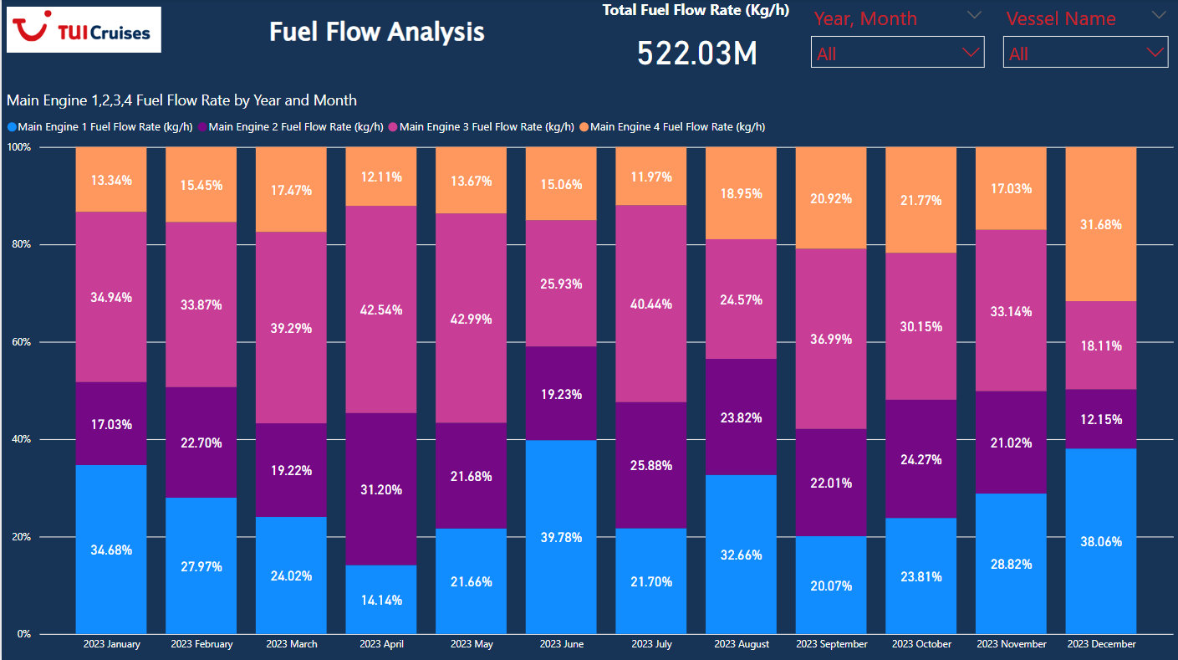

The above chart presents a breakdown of the **total** fuel flow rate for a vessel, likely a cruise ship operated by TUI Cruises, over the year 2023. The data is segmented by month and further categorized by each of the four main engines.

**Key Findings:**

* **Total Fuel Consumption:** The vessel consumed a total of 522.03 million kg of fuel in 2023.
* **Seasonal Variation:** Fuel consumption is highest in the later months of the year (September - December) and lowest in the earlier months (January - March). This suggests higher operational demands during the later months, potentially aligning with peak travel seasons.
* **Engine Contribution:** Engine 3 consistently consumes the most fuel, followed closely by Engine 1. Engine 4 uses the least amount of fuel throughout the year. This could indicate differences in engine size, load distribution, or operational requirements for each engine.

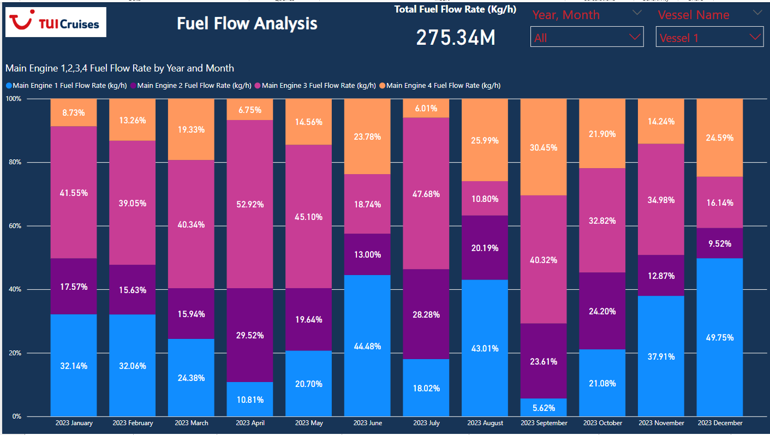

**Key Insights:**

* **Total Fuel Consumption:** The vessel consumed a total of 275.34 million kg of fuel in 2023.
* **Seasonal Variation:** Fuel consumption is highest in the later months of the year (September - December) and lowest in the earlier months (January - March). This suggests higher operational demands during the later months, potentially aligning with peak travel seasons.
* **Engine Contribution:** Engine 3 consistently consumes the most fuel, followed closely by Engine 1. Engine 4 uses the least amount of fuel throughout the year. This could indicate differences in engine size, load distribution, or operational requirements for each engine.

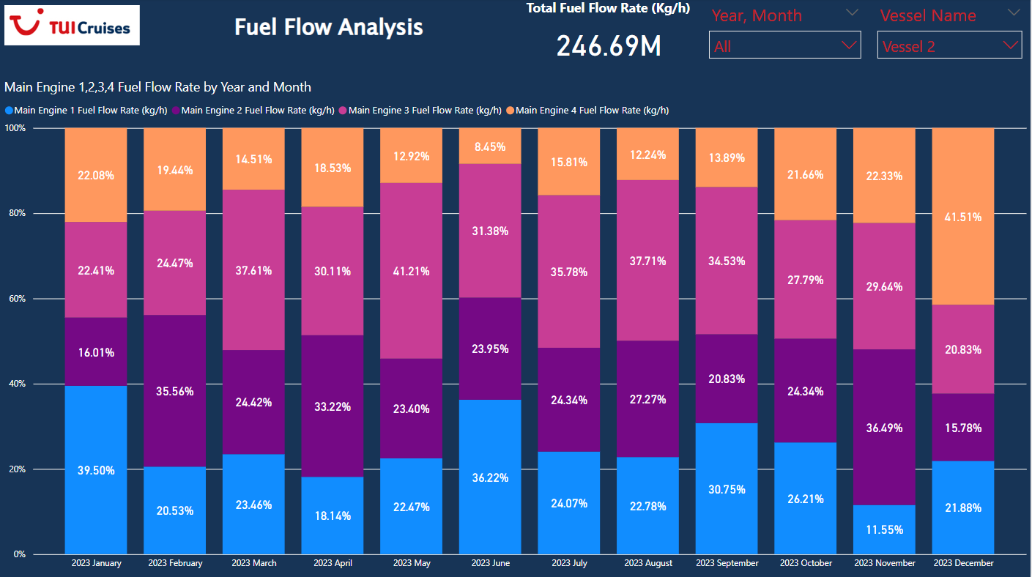

The stacked bar chart visualizes fuel flow rate data for four main engines of Vessel 2, broken down by month for the year 2023.

Here's a breakdown of the analysis:

**Overall Insights:**

* **Total Fuel Consumption:** The vessel consumed a total of 246.69 million kg of fuel in 2023.
* **Engine Contribution:** Each colored portion of a bar represents the contribution of a specific engine to the total fuel consumption for that month.
* **Engine 2 Dominance:** Engine 2 (purple) consistently had the highest fuel consumption throughout the year.
* **Seasonal Variation:** Fuel consumption shows some seasonal variation. It appears to peak in the middle of the year (around June and July) and is lowest at the beginning and end of the year.

**Month-by-Month Trends:**

* **January:** Engine 1 (blue) had the highest contribution, followed by Engine 2.
* **February - April:** Engine 2's contribution significantly increased, becoming the primary consumer.
* **May - August:** Engine 2 remained dominant, with noticeable peaks in June and July.
* **September - December:** Engine 2's contribution decreased, while Engine 1 and Engine 3 (orange) showed some increase in consumption.

# Power Consumption Analysis

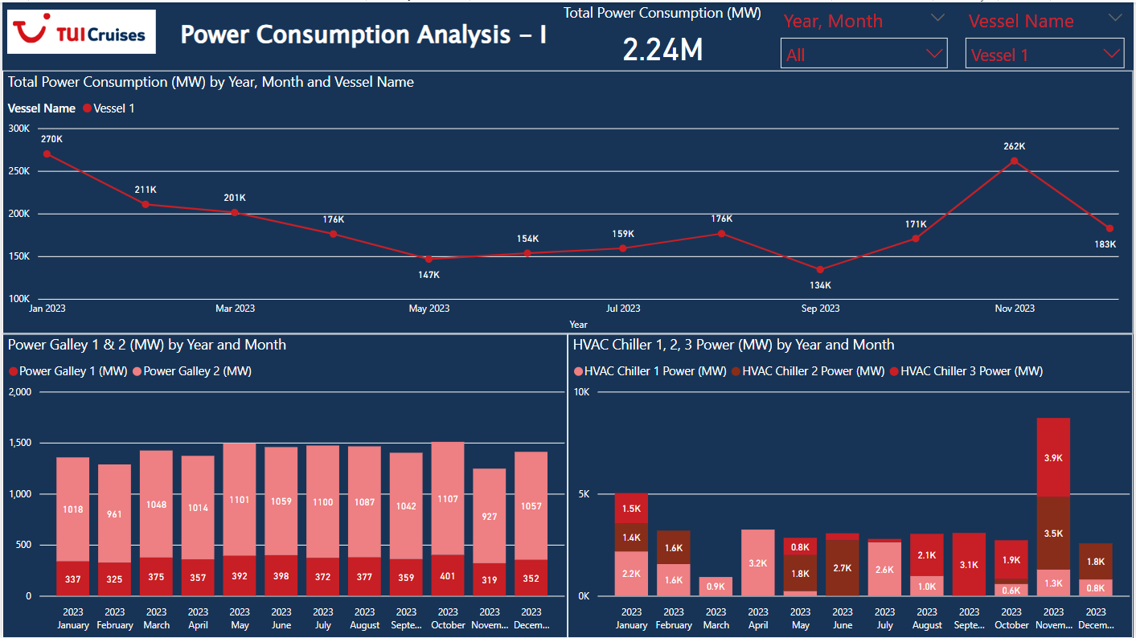

Power usage patterns on Vessel 1:

**Overall Power Consumption:**

* **High Consumption:** Vessel 1 has a high overall power consumption, reaching 2.24 MW. This suggests a large vessel with significant energy demands.
* **Peak Usage in November:** A significant peak in power consumption is evident in November 2023 (262K), indicating a period of heightened activity or potentially colder climate requiring more energy.

**Power Consumption Trends:**

* **Gradual Decline then Increase:** Total power consumption shows a gradual decline from January to May 2023, followed by a steady increase culminating in the November peak. This pattern might be influenced by seasonal changes or operational factors.

**Power Galley Insights:**

* **Consistent Power Usage:** The power galleys (likely kitchens) demonstrate relatively consistent power usage throughout the year with a slight increase from September onwards. This suggests a stable demand for food services onboard.

**HVAC System Insights:**

* **Chiller 1 Dominates:** HVAC Chiller 1 consistently demands the most power throughout the year, indicating it's likely the primary cooling system and potentially a significant energy consumer.
* **Increased Cooling Demand in Summer:** A noticeable spike in Chiller 1's power consumption is observed from June to August, aligning with warmer months and increased cooling requirements.

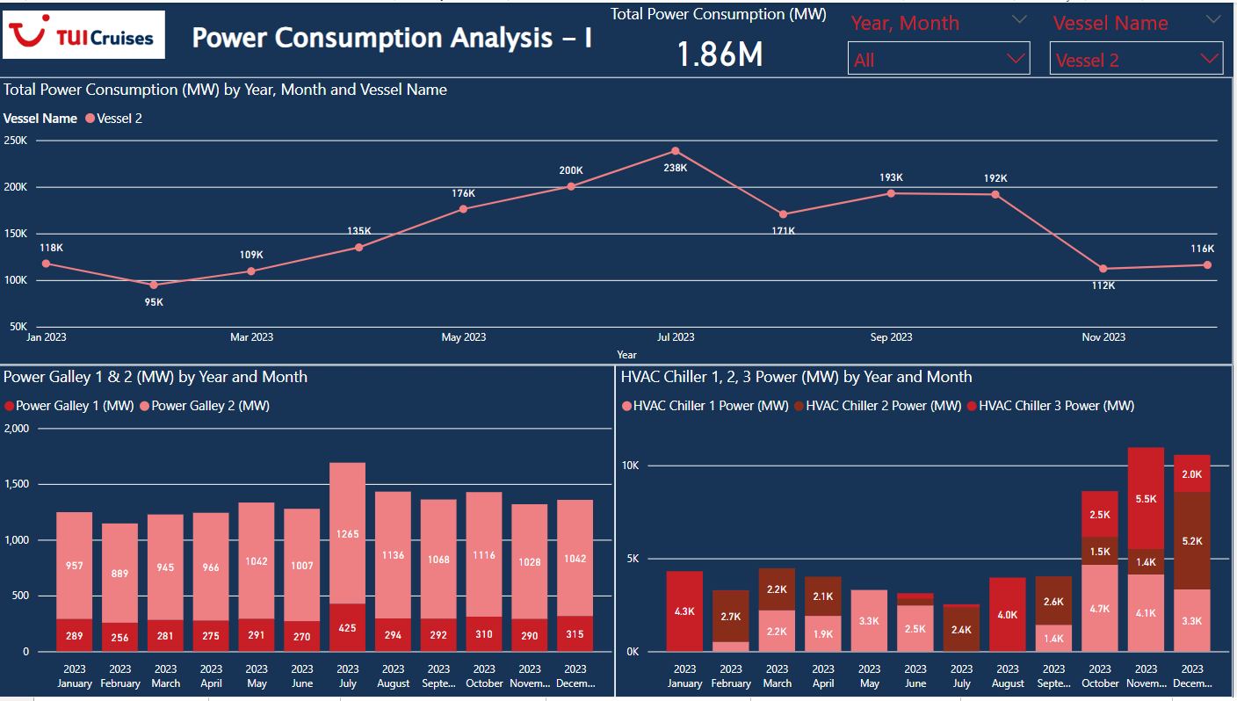

Cruise ship (Vessel 2) managed by TUI Cruises, spanning from January 2023 to December 2023.

**Key Components & Insights:**

1. **Total Power Consumption (MW)**
   * The top section provides a year-long overview of Vessel 2's total power consumption, revealing a peak in July (238K MW) and a significant dip in November (112K MW). This suggests possible seasonal trends in energy usage, perhaps correlated with guest occupancy or itinerary demands.
2. **Power Consumption (MW) by Year, Month, and Vessel Name**
   * This line chart breaks down the power consumption by month. Key observations include:
   * A steady upward trend from January to July
   * A sharp peak in July, followed by a decline towards the end of the year.
   * This chart likely helps identify periods of high energy usage for better resource allocation and potential cost-saving measures.
3. **Power Galley 1 & 2 (MW) by Year and Month**
   * This bar chart delves into the power consumption of two galley areas (likely kitchens) on the ship.
     + Power Galley 1 consistently consumes less power than Power Galley 2 throughout the year.
     + Both galleys show a peak in July, mirroring the overall power consumption trend. This suggests a correlation between galley usage and overall passenger numbers.
4. **HVAC Chiller 1, 2, 3 Power (MW) by Year and Month**
   * This bar chart analyzes the power consumption of the ship's HVAC (Heating, Ventilation, and Air Conditioning) system.
     + HVAC Chiller 1 is the primary energy consumer, with peaks in January and July, likely reflecting increased heating and cooling demands during those months.
     + HVAC Chillers 2 & 3 show significantly lower power usage, with Chiller 2 exhibiting a noticeable peak in July.

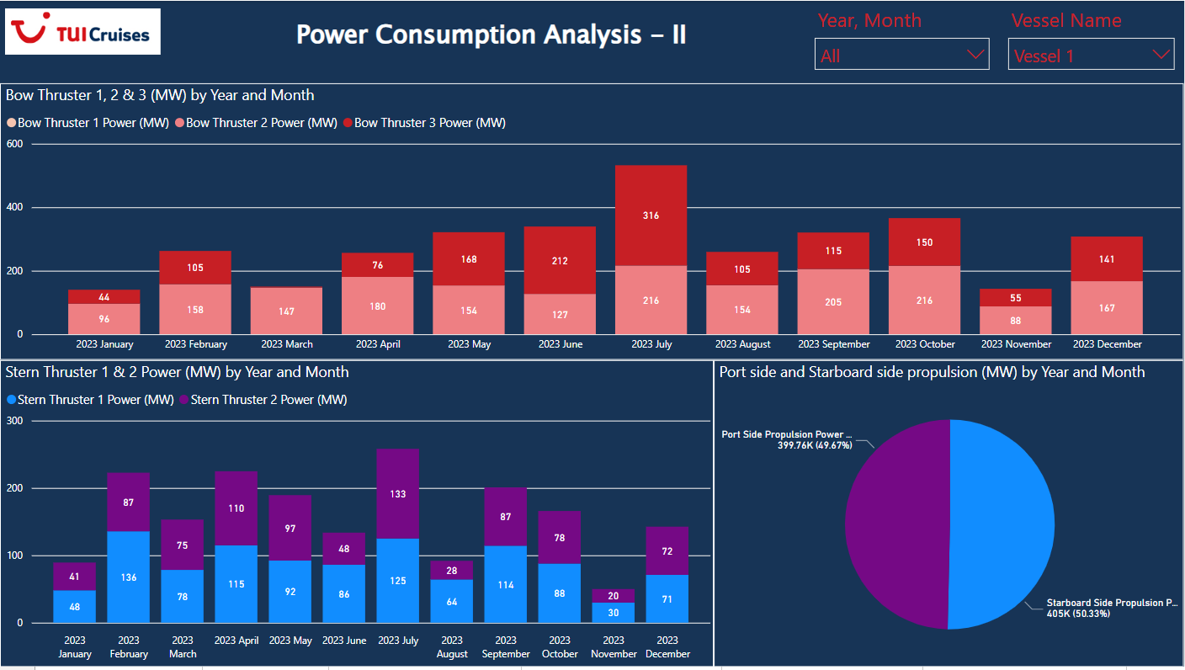

The dashboard presents a comprehensive analysis of power consumption for a vessel (Vessel 1), categorized by propulsion systems and time periods.

**Key Insights**

* **Bow Thrusters:** Bow thruster 3 consistently consumes the most power, peaking in July. Bow thruster 1 has significantly lower power consumption across all months.
* **Stern Thrusters:** Stern thruster 2 generally consumes more power than stern thruster 1, with peak usage in July for both.
* **Propulsion Power Distribution:** The vessel relies slightly more on starboard side propulsion (50.33%) compared to port side propulsion (49.67%).
* **Seasonal Trends:** July stands out with the highest power consumption across all propulsion systems, suggesting potentially higher vessel activity or demanding sailing conditions during that month.
* The pie chart, titled "Port side and Starboard side propulsion (MW) by Year and Month," illustrates the power distribution between the port and starboard propulsion systems.
* **Port Side Propulsion Power:** Constitutes 49.67% of the total power, represented by the purple section of the pie chart. The exact value is 399.76K.
* **Starboard Side Propulsion Power:** Makes up the remaining 50.33% of the total power, represented by the light blue section of the pie chart. This equates to 405K.
* This visualization suggests that the starboard side propulsion system consumed slightly more power than the port side during the period analyzed.

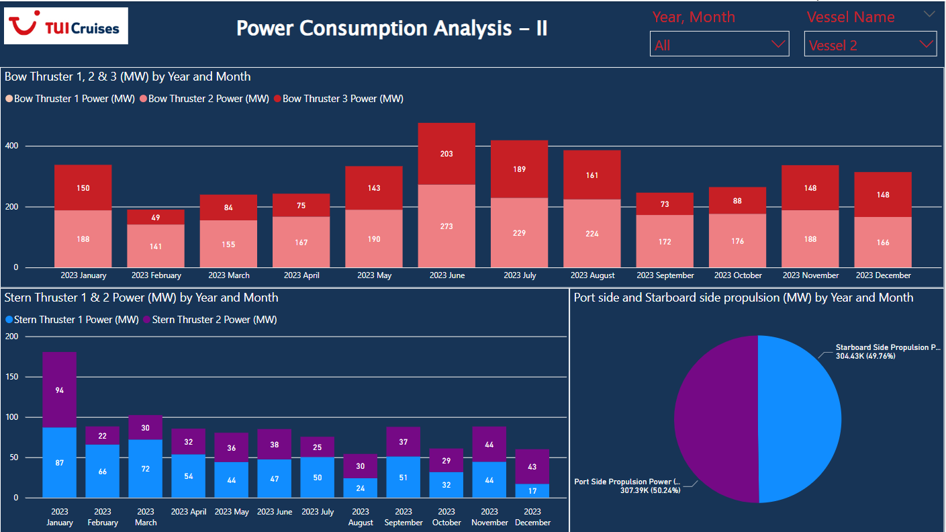

The above visualizations offer a detailed analysis of the power consumption of a vessel over the course of 2023, categorized by propulsion systems and time periods.

**Key Insights:**

* **Bow Thrusters:** Bow thruster 3 consistently consumes the most power throughout the year, with a peak in July.
* **Stern Thrusters:** Stern thruster 2 generally consumes more power than stern thruster 1, with both experiencing their highest consumption in July.
* **Propulsion Power Distribution:** The vessel relies slightly more on starboard side propulsion (50.33%) compared to port side propulsion (49.67%).
* **Seasonal Trends:** July stands out with the highest power consumption across all propulsion systems, potentially indicating higher vessel activity or demanding sailing conditions during that month.

# Environmental Impact Analysis

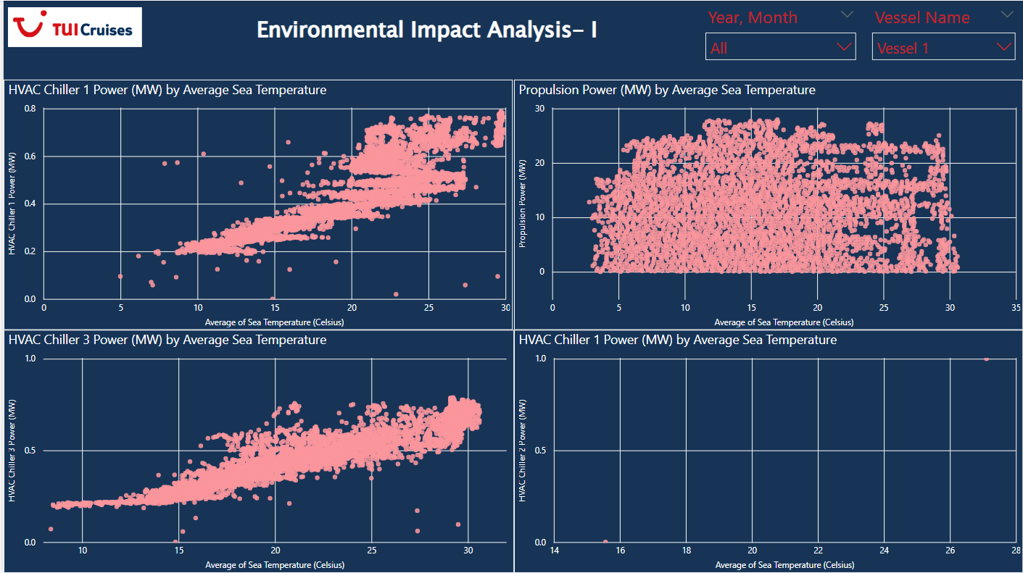

**Increased HVAC Power with Higher Sea Temperature**:

* Both **HVAC Chiller 1** and **HVAC Chiller 3** consume significantly more power as sea temperature rises, indicating a direct relationship between external sea temperature and onboard cooling demand.

**Propulsion Power is Independent of Sea Temperature**:

* **Propulsion Power** remains relatively constant across varying sea temperatures, suggesting external factors like ship speed, distance, or operational conditions have a greater influence on propulsion power usage than environmental conditions like sea temperature.

**Data Gaps in HVAC Chiller 2**:

* There is sparse data for **HVAC Chiller 2**. This could either be due to a lack of operational usage, issues with data collection, or infrequent activation compared to the other chillers.

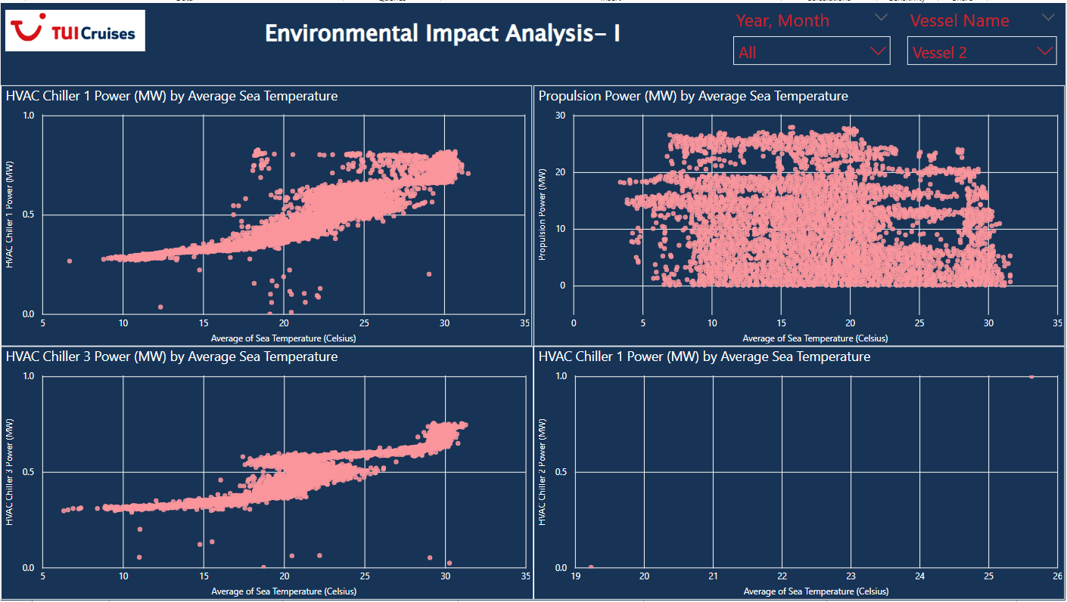

**HVAC Chiller Power Consumption (Chillers 1 & 3):**

* **Increasing trend with temperature**: Both HVAC Chiller 1 and 3 show a clear increase in power consumption as sea temperature rises, especially beyond 15°C. This indicates that the cooling system has to work harder in warmer conditions, with power consumption stabilizing around **0.5 MW** for sea temperatures between **20°C and 30°C**.
* **Outliers**: There are some outliers in the higher temperature range, suggesting occasional spikes in power usage that could be due to operational factors or environmental conditions.
* **Stable range**: At lower temperatures (below 15°C), power consumption for both chillers is relatively low and stable, with a gradual increase as the temperature rises.

**HVAC Chiller 2 Power Consumption:**

* **Limited data range**: HVAC Chiller 2 is only shown for a narrow range of temperatures (19°C to 26°C), making it harder to draw concrete conclusions.
* **Low power usage**: The power consumption remains consistent and low (below **0.5 MW**) within the temperature range, suggesting a different operational pattern or cooling load compared to Chillers 1 and 3.

**Propulsion Power Consumption:**

* **Wide variation**: Propulsion power varies greatly, but typically remains within the range of **10 to 30 MW** across different sea temperatures.
* **Little correlation with temperature**: Unlike the HVAC Chillers, there doesn't appear to be a strong correlation between sea temperature and propulsion power. The power usage stays relatively constant, with some scattered points below **10 MW**, particularly at lower sea temperatures (below 10°C), possibly representing instances of low-speed cruising or idling.

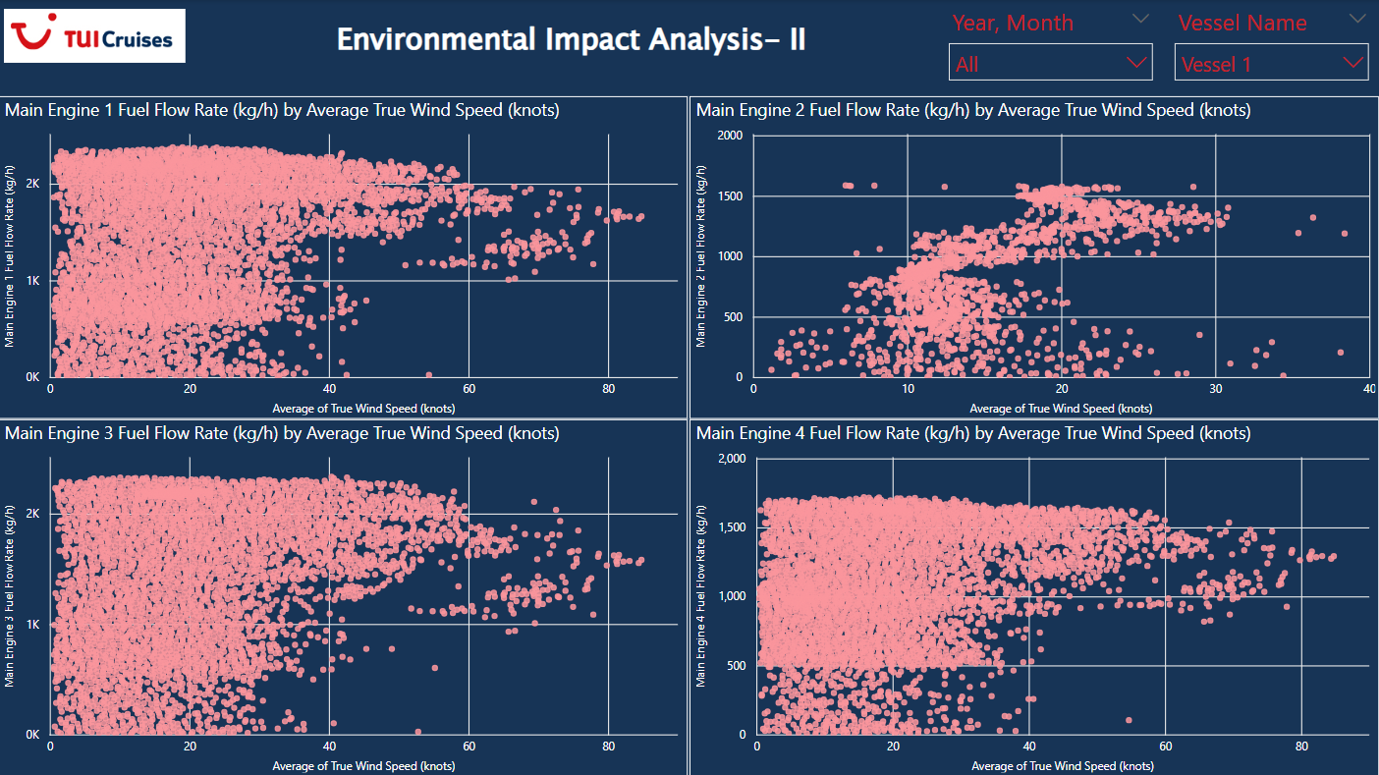

**Main Engines 1 and 3**:

* Both engines exhibit similar behaviour with **high and stable fuel consumption (2000 kg/h)** across most wind speeds (0 to 40 knots).
* There is more variability at higher wind speeds (above 40 knots), suggesting that these engines are more sensitive to wind conditions.
* Some data points represent lower fuel consumption at higher wind speeds, but this seems to be less frequent.

**Main Engines 2 and 4**:

* These engines exhibit **lower and more variable fuel flow rates** (500-1500 kg/h) across lower wind speeds (0 to 20 knots).
* They stabilize between 1000 and 1500 kg/h as wind speeds increase, with fewer fluctuations compared to Engines 1 and 3.
* Engine 4, in particular, shows consistent performance, with minimal changes even as wind speeds increase, indicating a more consistent and efficient fuel usage pattern.

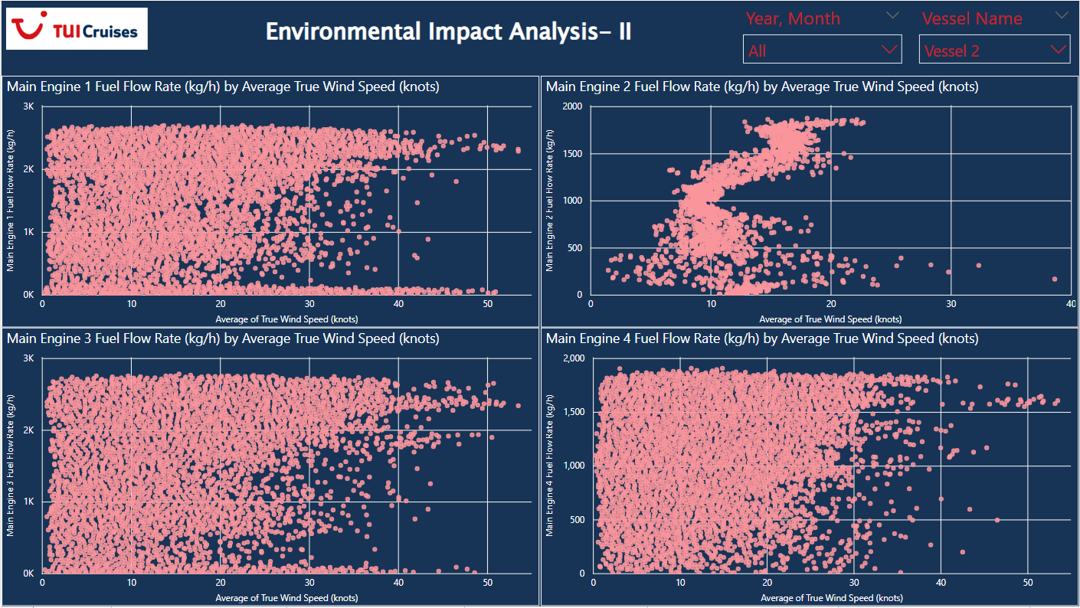

**1. Main Engine 1 Fuel Flow Rate**

* **Range of Wind Speed**: The graph shows wind speeds from 0 to over 50 knots.
* **Fuel Flow Rate Pattern**: The fuel flow rate seems quite consistent, generally between 1000 and 3000 kg/h, across all wind speeds, though it does tend to slightly increase with wind speeds beyond 30 knots.
* **Clustering**: There is heavy clustering around wind speeds between 0 and 30 knots, indicating a large amount of data for those wind speeds. There seems to be a clear trend of increasing fuel flow with increasing wind speed beyond 30 knots.

**2. Main Engine 2 Fuel Flow Rate**

* **Range of Wind Speed**: This engine's fuel flow rate is plotted against wind speeds from 0 to about 40 knots.
* **Fuel Flow Rate Pattern**: The data is more spread out compared to Main Engine 1, with fuel flow rates between 0 and 1500 kg/h. There appears to be a more erratic distribution, especially beyond 20 knots.
* **Clustering**: Significant clustering of fuel flow rates below 10 knots, but a wider spread in fuel flow rates is evident with increasing wind speeds. There is some notable fluctuation between 10 to 20 knots, indicating variability in performance.

**3. Main Engine 3 Fuel Flow Rate**

* **Range of Wind Speed**: Similar to Main Engine 1, wind speeds go from 0 to 50 knots.
* **Fuel Flow Rate Pattern**: The fuel flow rate is clustered tightly between 1000 and 2500 kg/h, with less variation compared to Main Engine 2. At lower wind speeds (under 10 knots), fuel flow rate remains somewhat stable but does show some spread as wind speeds increase.
* **Clustering**: Like Main Engine 1, the data shows a tighter cluster in the lower wind speeds, indicating consistent performance up to 30 knots. However, beyond 30 knots, the fuel consumption increases but is not as tightly clustered as Main Engine 1.

**4. Main Engine 4 Fuel Flow Rate**

* **Range of Wind Speed**: Wind speeds go up to 50 knots for this engine.
* **Fuel Flow Rate Pattern**: The fuel flow rate is fairly consistent at around 1000 to 1500 kg/h, with much less variation compared to the other engines.
* **Clustering**: There is significant clustering in the 1000-1500 kg/h range regardless of wind speed, which suggests that this engine may not be as sensitive to changes in wind speed as the others. The tight clustering might indicate this engine is more stable in terms of fuel consumption.

# 

# Navigation and Vessel Performance

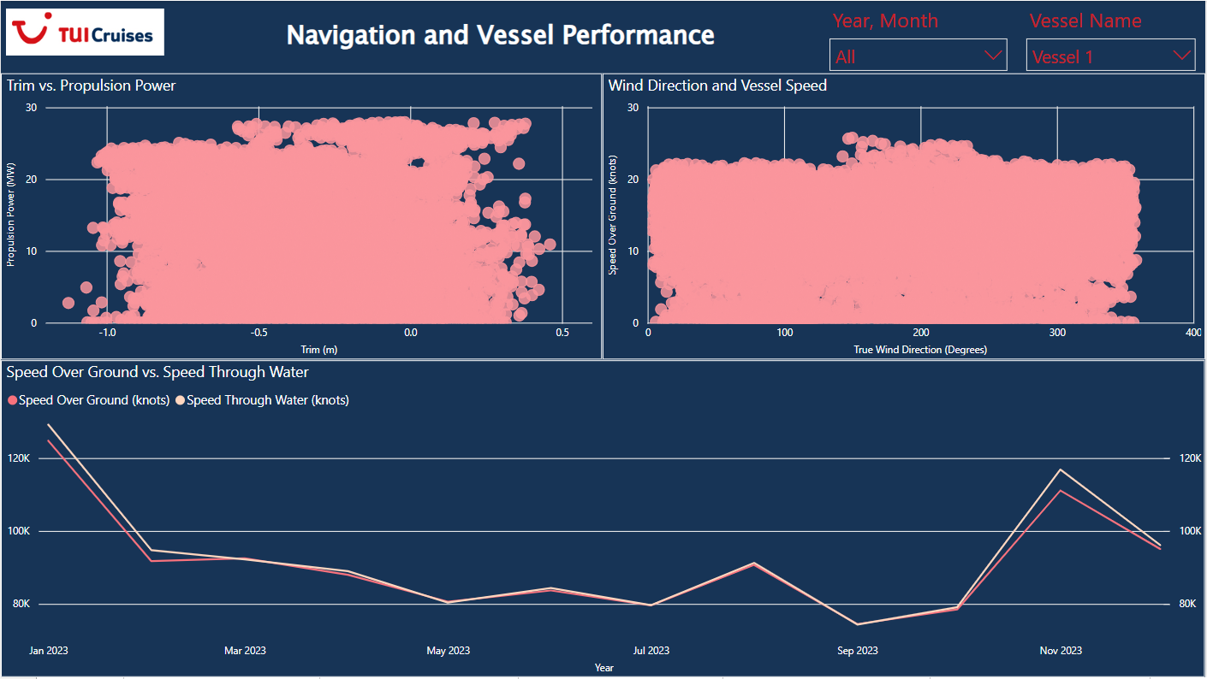

The above chart is another dashboard titled "Navigation and Vessel Performance," this time for **Vessel 1**.

**1. Trim vs. Propulsion Power (Top Left)**

* **X-Axis (Trim)**: The trim is measured in meters (m), ranging from approximately -1.0m (aft) to 0.5m (bow).
* **Y-Axis (Propulsion Power)**: Propulsion power is measured in kW, ranging from 0 to around 30kW.
* **Observation**:
  + The trim values are mainly clustered around the neutral point (-0.5m to 0.2m), indicating that the vessel mostly operates with minimal bow or aft trim.
  + There is a wide distribution of propulsion power, with most values concentrated between 10kW and 25kW.
  + A slight positive trim seems to coincide with higher propulsion power usage, suggesting that when the vessel is slightly bow-trimmed, more propulsion power is used.
  + Very few data points appear for extreme trims (closer to -1m or 0.5m), indicating that the vessel may rarely operate under such conditions.

**2. Wind Direction and Vessel Speed (Top Right)**

* **X-Axis (True Wind Direction)**: This ranges from 0° to 400°, representing the wind direction relative to the vessel's heading.
* **Y-Axis (Speed Over Ground)**: The speed of the vessel (knots) ranges from 0 to about 30 knots.
* **Observation**:
  + There seems to be little correlation between wind direction and the vessel's speed over ground, as the speed appears consistent regardless of the direction.
  + The data is densely clustered between 5-20 knots of speed, which might represent the common operating speed range for the vessel.
  + The wide spread across all wind directions (0° to 400°) suggests that the vessel operates in varying wind conditions with consistent speeds.

**3. Speed Over Ground vs. Speed Through Water (Bottom)**

* **X-Axis (Year)**: The months are represented along the timeline from **Jan 2023 to Nov 2023**.
* **Y-Axis (Speed in Knots)**: The scale goes from 80,000 to 120,000, which seems to represent cumulative speed data points for both **Speed Over Ground** and **Speed Through Water**.
* **Observation**:
  + The red and pink lines correspond to Speed Over Ground and Speed Through Water, respectively. The trends for both appear very similar, indicating that there is not much variation between the vessel’s movement through water and the effective speed over the ground.
  + From January 2023 to around July 2023, there is a consistent decline in both metrics, with the lowest points appearing around **September 2023**. This could indicate slower operational months, lower performance, or external factors like weather conditions affecting speed.
  + After September 2023, both speeds experience a sharp rise in November 2023 before tapering off again. This could reflect seasonal changes, changes in operations, or specific voyages during that period.

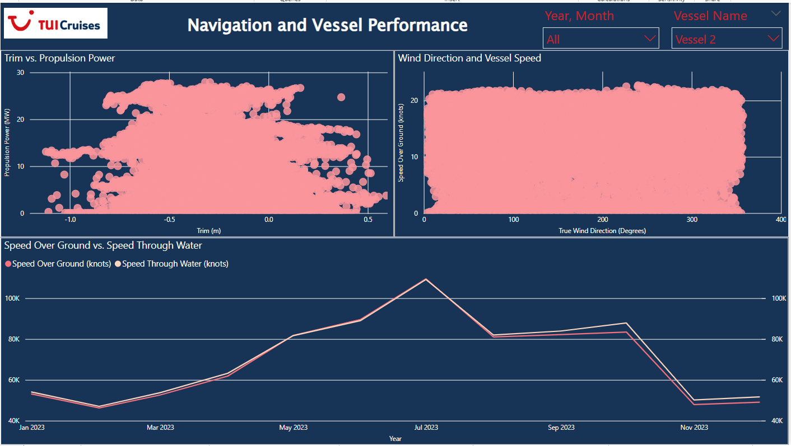

The above chart is another dashboard titled "Navigation and Vessel Performance," this time for **Vessel 2**.

**1. Trim vs. Propulsion Power (Top Left)**

* **X-Axis (Trim)**: Similar to Vessel 1, the trim is represented in meters (m), ranging from -1.0m to 0.5m.
* **Y-Axis (Propulsion Power)**: Propulsion power is measured in kilowatts (kW), ranging from 0 to 30kW.
* **Observation**:
  + The propulsion power shows wide variation, with the majority of data points concentrated between 10kW and 25kW, indicating common operating conditions.
  + A high number of data points are clustered around neutral trim (between -0.5m and 0.0m), suggesting that the vessel primarily operates with minimal trim.
  + Similar to Vessel 1, slight bow trims (positive trim) are associated with higher propulsion power, and few extreme trim cases appear beyond -1.0m or 0.5m.
  + The distribution of data points seems slightly less dense compared to Vessel 1, possibly indicating more varied trim conditions in Vessel 2's operations.

**2. Wind Direction and Vessel Speed (Top Right)**

* **X-Axis (True Wind Direction)**: This goes from 0° to 400°, representing the wind direction relative to the vessel.
* **Y-Axis (Speed Over Ground)**: The vessel speed over ground (knots) ranges from 0 to about 30 knots.
* **Observation**:
  + Similar to Vessel 1, there seems to be little correlation between wind direction and vessel speed over ground, as the speed remains consistent across all wind directions.
  + The vessel’s speed primarily falls between 5 and 20 knots, which likely represents its regular cruising speeds.
  + The pattern appears quite consistent, indicating stable performance across varying wind conditions for Vessel 2.

**3. Speed Over Ground vs. Speed Through Water (Bottom)**

* **X-Axis (Year)**: The timeline shows months from January 2023 to November 2023.
* **Y-Axis (Speed in Knots)**: The scale ranges from 40,000 to 100,000 cumulative points, representing **Speed Over Ground** and **Speed Through Water**.
* **Observation**:
  + Both Speed Over Ground and Speed Through Water follow very similar trends, with only minor differences between them, suggesting consistent vessel performance relative to water and ground movement.
  + The trend differs from Vessel 1 in that speeds **increase steadily** from January 2023 until **July 2023**, peaking around 100K knots in July. This indicates higher speeds or operational activity during that period.
  + After July, there is a **sharp decline** in speeds, hitting a low around **October/November 2023**. This could suggest either a reduction in operational activity or slower voyages in this period.
  + In contrast to Vessel 1, Vessel 2 shows a notable rebound in speed toward the end of 2023, which may indicate resumption of higher activity.

**Comparison with Vessel 1**

* Both vessels show a similar lack of correlation between wind direction and speed.
* While Vessel 1 saw a dip in speed during the middle of the year, Vessel 2 experienced a peak in the middle and a sharper decline later, showing contrasting operational trends.
* Vessel 2's propulsion power vs. trim distribution is more dispersed, indicating potentially greater variation in its operating conditions compared to Vessel 1.

Geospatial Analysis  
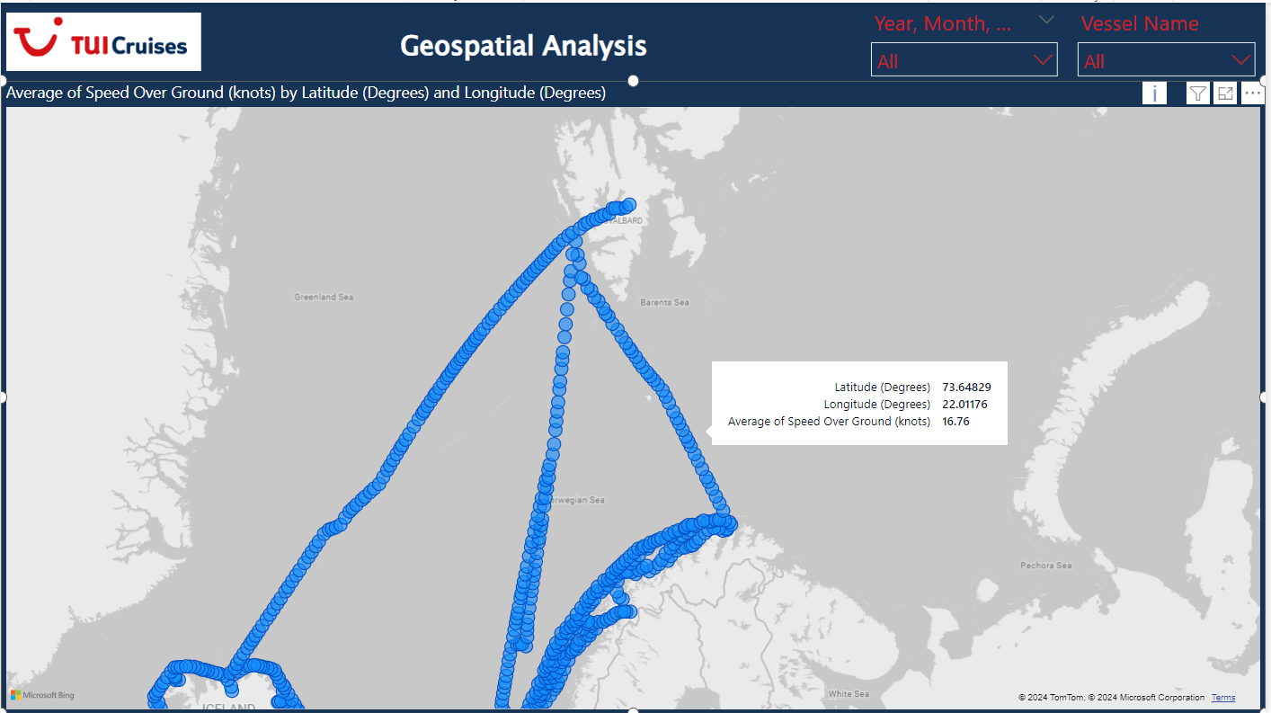

**Regional Route Focus**: The vessel's routes shown are **concentrated in the Arctic region**, suggesting that the data being displayed is likely focused on a **particular cruise or set of voyages** in that area. The global route coverage is not visible, limiting the analysis to this region.

**Speed Data Points in a Limited Area**: The **speed data** (e.g., 16.76 knots) is shown for this limited geographic range. If global routes are intended, this focus on a small region doesn't provide insight into vessel performance on a wider scale.

**Filtering Issues**: The filters for **Year, Month**, and **Vessel Name** imply that the user can view data across different timeframes and vessels, but the current map snapshot only shows a **small section of the world**. The filters might not be fully utilized if the map remains focused only on this region.